2023 Press Ganey HX NDNQI® Award
Email Signature Template
Customize your Outlook signature with a 2023 Press Ganey HX NDNQI® Award Winner option below.

1. Copy the information below.
2. Open preferences.
3. Select Signatures.
4. Click the add button
5. Then paste.

All graphics should be automatically placed.

Option 1 – HX DNQI® Award Logo:

Name
Title
t. X.XXX.XXX.XXX
m. X.XXX.XXX.XXX
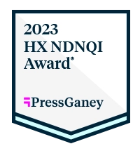

Option 2 – text only:

Name
Title
t. X.XXX.XXX.XXX
m. X.XXX.XXX.XXX
2023 Press Ganey HX NDNQI Award for Outstanding Nursing Quality® Winner

